

**WELCOME TO TALTECH SUMMER SCHOOL**

PRE-DEPARTURE INFORMATION

**2025**



WELCOME

We are very happy that you have chosen to participate in the Summer School in Tallinn with focus on Cyber Security. This information guide provides you few tips on what to expect when arriving to Estonia for the first time. If you have any questions, please don’t hesitate to contact us.

SUMMER SCHOOL THEME

2.1 Program

This course examines the role of cyberspace as a domain of operations for state and non-state actors. This was acknowledged by NATO in 2016 and is now regarded as an equal to operations on land, sea, air and space. As for the other domains, there are numerous distinct attributes to the cyber domain, which will be examined in turn to provide the students with a greater understanding of the issues involved. There is particular emphasis on the role of information and how the global reach of cyberspace can be exploited as a means to influence a target. The course highlights the complexity of the cyber landscape by illustrating how a range of separate disciplines including international relations and law are now integral to understanding its characteristics. The course also includes practical means to mitigate a range of cyberthreats by including elements of incident.

[LINK TO THE PROGRAM SCHEDULE](https://livettu-my.sharepoint.com/:x:/g/personal/maarja_tosso_taltech_ee/EXcN9e3bHfBEvO3MMnPUwyQBKeuS-f53OWkJIYk6cy7VSQ?e=n8fZig)

2.2 Study visits

We will have planned four exclusive study visits: Clarified Security, Center for Maritime Cybersecurity, NATO CCDCOE and CR14.

[**Clarified Security**](https://www.clarifiedsecurity.com/) is an Estonian cyber security company focused on delivering practical security services. Our home market is the "IT wonderland" of Estonia where Web is the glue and delivery mechanism of most of these wonders. Thus, our strongest focus has been on **manual WebApp pretesting**while being generally happy to break anything that offers us technical challenges.

[**Centre for Maritime Cybersecurity**](https://taltech.ee/en/estonian-maritime-academy/areas-of-advance/maritime-cyber-security)The research focus of the Centre is on developing innovative solutions to address the emerging security challenges in the maritime industry. This includes studying the threat landscape, identifying vulnerabilities in maritime systems, and developing cybersecurity measures to mitigate the risks posed by cyber-attacks. A key aspect of the research is to understand the unique challenges posed by the maritime environment, including e.g., limited connectivity and the need for real-time information exchange. Focusing on these specific areas, the Centre can ensure that its research has practical applications and can help to improve the cybersecurity of the maritime sector.

[**NATO CCDCOE**](https://ccdcoe.org/)Our mission is to support our member nations and NATO with unique interdisciplinary expertise in the field of cyber defense research, training and exercises covering the focus areas of technology, strategy, operations and law.

Our vision is to foster cooperation of like-minded nations. We bring together NATO Allies and partners beyond the Alliance.

We are proud to offer a unique interdisciplinary approach to the most relevant issues in cyber defense with our research, training and exercises.

[**CR14**](https://www.cr14.ee/)was Established by the Estonian Ministry of Defence in January 2021. CR14 is proud to offer cyber ranges, cyber exercise automation, a digital library and cybersecurity simulation tools as well as solutions that allow for the simple and effective planning and implementation of cyber defence exercises and activities. Our cyber-physical solutions – the power grid, 5G networks, military systems IoT etc. – also support specialised training, particularly for critical infrastructure providers.

CR14 is a government-owned and operated entity, which offers cybersecurity-related research and development for domestic and international; private and public sector partners. In addition to developing and maintaining NATO Cyber Range since 2014, CR14 also offers Host Nation Support to NATO CCDCOE.

2.3 Requirements

Attendance and active participation are mandatory for all participants.  Active participation encompasses proactive engagement in discussions and the formulation of relevant questions. Consistent engagement will result in successful completion of the course and will be rewarded with a certificate. In the event of emergencies, unforeseen illnesses, or other exceptional circumstances, students may be excused provided they inform the organizers in a timely manner. Punctuality is strictly observed, and attendance is documented daily through the collection of participation signatures.

2.4 Study outcomes

By completing the study program a student:

* has an understanding of the terminology associated with the cyber landscape, cyberthreats and cyber actors
* has gained an awareness of the role of cyberspace as a domain of warfare and how this relates to cybersecurity
* has a background understanding of how international relations apply to contemporary cybersecurity issues
* can apply an interdisciplinary approach to cyber security
* has an appreciation of the range of subjects that connect cyber security with wider global politics and the motivation of threat actors
* demonstrates the ability to work as an individual and as a team member or leader
* has developed an understanding of the role of cybersecurity in the maritime domain
* has a greater appreciation of the role of open-source material and social media in cybersecurity
* has an understanding and appreciation of the Estonia cyber landscape and cybersecurity ecosystem.

ACCOMMODATION

Accommodation is in Hessnery hostel. You will share a twin room with other participants from the same program.

The room has a wide bed, TV screen, stove, refrigerator, microwave, private bathroom with shower. Free and fast WiFi is available throughout the building.

The room is accessed with a **pin code**, that the system will send them directly to your email. The code has 4 numbers and # (example 1234#).

With the room pin code you can enter our hotel 24/7.

When you’re outside, press the check-in button code panel and enter the code to access the hotel and use the same code to enter your room.

Laundry room with washing machines and dryers and a fully equipped gym are located on the lower level. This code also grants access to these rooms.

You will find two towels (1 bigger, 1 smaller) in the room. Beddings and towels will be changed once during in the middle of your stay. If you want, you can wash your towels in the laundry room.

See more pictures of the rooms and the building from [**HERE**](https://hessnery.ee/gallery/)

[GOOGLE MAPS LINK](https://maps.app.goo.gl/91r9M28nBEF4sQ6B7)

GETTING AROUND

You can use public transport to easily get around in the city. Buses and trams cover the whole city and we also have night buses (e.g bus 18 from city center to Hessnery hostel). We will provide you with a unlimited public transportation card (Ühiskaart) on the first day during the briefing session.



or

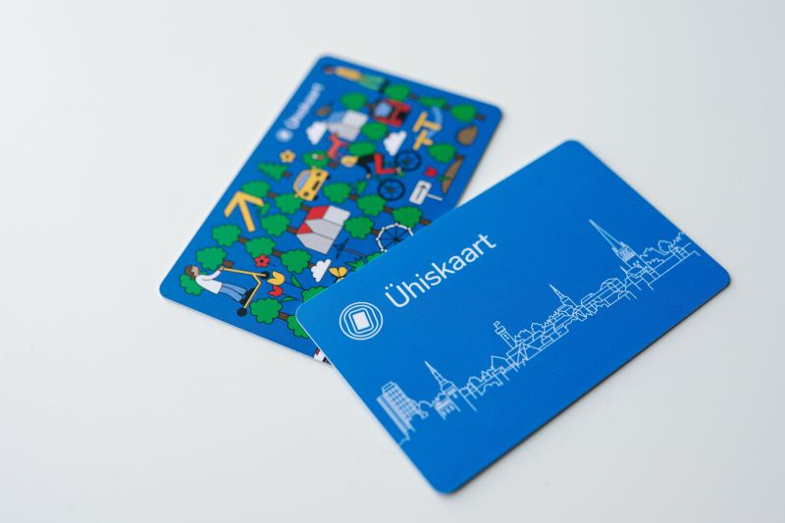

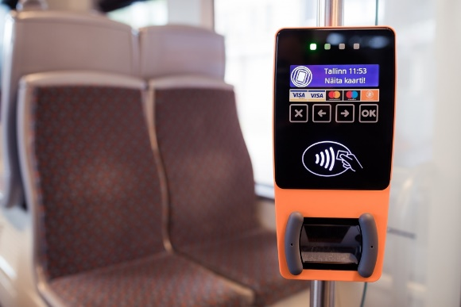You can enter bus/tram from any door. For validation look for orange-colored box near the door. You need to beep your card once upon each entry to every vehicle you use. Don’t beep it when you leave the bus.

In an unlikely event of ticket-check the whole bus will be stopped between two bus-stops, offcials in green suits will enter and ask for each persons’ ticket. You need to present this green card and they check with their scanner-reader if you have validated your ride.

If you want to explore the city before you get your travel card, you can use your contactless bank card to validate 1hour ticket from the validator on the first door entrance.

Read more about ticket information [**here**](https://www.tallinn.ee/en/pilet/public-transport-tickets-tallinn)

Bus schedules are [**here**](https://transport.tallinn.ee/#tallinna-linn/map/en)

**Journey planner is** [**here**](https://transport.tallinn.ee/#plan//en)

Locals use [**Bolt app**](https://bolt.eu/en-ee/)for taxi, and also car and scooter rental. Also [**Tuul app**](https://tuul.xyz/en/#pll_switcher) for Tuul scooters. [**And Ride Mobility**](https://ridemobility.eu/) for mopeds. These scooters are available on most parts of the campus and all over the city.

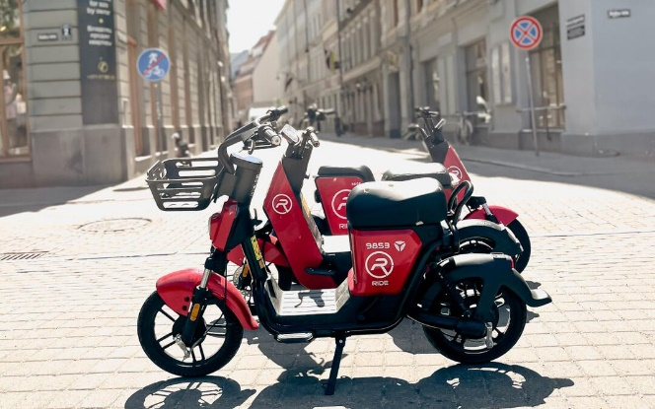

If you want a regular taxi then [**Forus**](https://forustakso.ee/en/)is the biggest company, their dispatchers speak English and the drivers are trustworthy and reliable. They also have cars in front of the airport waiting.

Bolt from the airport to Hessnery is around 15-25 euros (depending on the time of the day).

Depending on the arrival times we also try to organize transfer bus from the airport to the hostel if many students arrive at the same time. **If you know when you plan to arrive in Tallinn please let us know so we can start planning.**

To TalTech campus

There is a bus stop in from of the hostel for bus n 10 and no 27. Bus stop name is “[Pärnu maantee](https://maps.app.goo.gl/fj1MoUc8rFGh7rHr8)” and it will take you directly to Taltech campus, the bus stop you need to come off each day is “[Tehnikaülikool](https://maps.app.goo.gl/Jpvu7W25vdeBXiEo6)”.

[Schedule for bus 10](https://transport.tallinn.ee/#bus/10/b-a/04403-1/en)

[Schedule for bus 27](https://transport.tallinn.ee/#bus/27/b-a/04403-1/en)

To return to hostel use the same names and numbers just the opposite direction.

Most lectures take place in TalTech's ICT building, Akadeemia tee 15a, 7th floor, room 701. Goole maps: <https://g.co/kgs/wUd3pn9>. 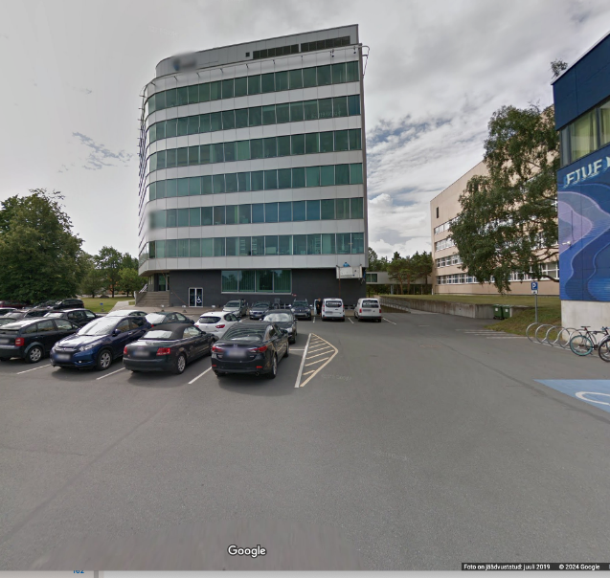

When you enter the main door of the building, the 1st elevators are on your right. Go to the 7th floor and you can find room 701 by going straight through the hall.

To the center

From the hostel take direct bus no 18 to “Vabaduse Väljak”. This is the main square, you can walk to old town from there.

CANTEEN

Breakfast and lunch will be served in the main canteen.

Plus Kohvik TalTech - Akadeemia tee 3

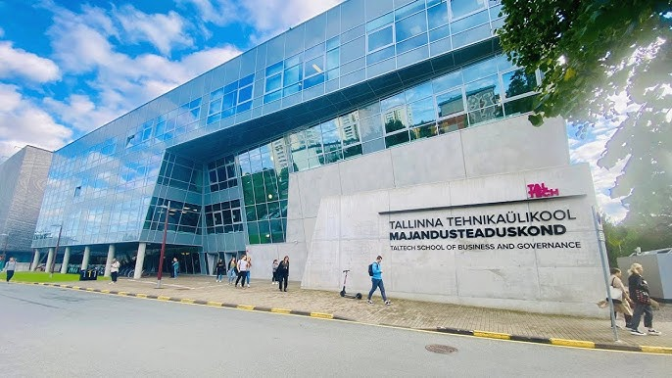

Google maps: <https://g.co/kgs/hAPFWSz>

Breakfast and lunch have been pre-paid for you: 5,5 euros for each breakfast and 10 euros for each lunch. The breakfast and lunch voucher is a TalTech branded wristband, that you need to show each time. You will receive your wristband on the first day.

The canteen is a buffet, so you can choose what you like and put it on the tray. If you want a hot meal, then ask from the lady behind the counter. Then proceed to the cashier with your tray. She will calculate the sum of the items on your tray. This is when you show your wristband. If the price is over the amount (breakfast 5,5 euros/lunch 10 euros) they will ask you to pay for the extra amount.

There are some days we won’t be doing classes on campus (visit to Clarified Security and visit to Maritime Cyber Security center). Those mornings there is a breakfast pack in for you in the hostel kitchen. Lunch will be included in a nearby canteen.

In Narva breakfast is included in the hostel and we’ll also eat lunch there.

In the evenings and during weekends you can cook in your hostel room. A groceries store is located just in front of the hostel.

NARVA

As part of the program we will also take an overnight trip to Narva - a border city that is dived from Russia by a great river. We will go there with a coach bus, drive there is appx. 3,5 hours. After arrival we’ll check-in to the hostel, eat lunch and then have a walking tour. Next day we will also visit a historic fortress originally built in 13th century on a strategic location along the Narva river, that made it a crucial stronghold throughout history. Today it’s a popular tourist site and a cultural heritage site.

After that we will return to Tallinn and you will have free time in the evening.

ACTIVITIES

On the first day we’ll go to Tallinn [old-town](https://www.visittallinn.ee/eng/visitor/see-do/neighbourhoods/old-town) walking tour. Tallinn old town is part of UNESCO world heritage and one of the best preserved medieval cities in the world.

During the first week we will visit the KGB museum in Viru Hotel.

Once upon a time, there was a hotel called Viru. The year was 1972 and a little less than 20 years remained until the end of the Soviet era. The hotel for foreigners also had to suit the national security body – [**KGB**](https://en.wikipedia.org/wiki/KGB)!

We also have planned to have some Estonian movie nights. For example [**Melchior the Apothecary**](https://www.imdb.com/title/tt13332268/)-a medieval crime thriller about a Tallinn pharmacist who has to uncover the secret behind a terrible wave of murders.

We have some games we can play together on the campus or you can borrow to play in the hostel. For example basketball, volleyball, [**Mjölkki**](https://www.molkky.com/game/rules/)**,** [**Maffia**](https://en.wikipedia.org/wiki/Mafia_(party_game))**,** [**Exploding Kittens**](https://en.wikipedia.org/wiki/Exploding_Kittens)**,** [**Uno**](https://en.wikipedia.org/wiki/Uno_(card_game)) etc.

You will also have plenty of free time to enjoy Estonian summer, or explore the city of Helsinki in Finland or Riga in Latvia on your own. If the weather is good you can also go to one of the beaches (**[Kakumäe](https://maps.app.goo.gl/CLm7v73RELsRZbVZ7) rand,** [**Stroomi rand**](https://maps.app.goo.gl/aXRwwHnJ4TZmnM1GA)**,** [**Pirita rand**](https://maps.app.goo.gl/9ceof5pz6BTk4fVE9)) and you can also swim in the Baltic sea.

Close to the Hostel is also [**Harku forest**](https://g.co/kgs/MKS8nqS) health trails where you can go jogging or walking.

EXTRA INFO

8.1 Essential vocabulary

Hello = Tere

Goodbye = Head aega

Thank you = Aitäh

Please = Palun

Here’s a [**LINK**](https://www.speaklanguages.com/estonian/phrases/basic-phrases#google_vignette) with some basic phrases.

For the next level learners, try to spell: “öötöö” (night job) and “jäääär” (edge of ice).

8.2 Shopping

Main shopping centers that most people go to for more groceries, pharmacies, clothes, free time [Rocca al Mare](https://www.roccaalmare.ee/), [Kristiine Keskus](https://www.kristiinekeskus.ee/), [Ülemiste Keskus](https://www.ulemiste.ee/).

Nice department store in the center [Tallinna Kaubamaja](https://www.kaubamaja.ee/) (+ it’s connected to [Viru Keskus](https://virukeskus.com/), that has a nice street food options).

If you have time, then [Balti Jaama turg](https://en.astri.ee/bjt/) (Baltic Train Station Market) is also a fun place to visit for variety of street food, antiquities, etc.

Most grocery stores like Selver, Coop, Rimi and Prisma, Lidl offer large varieties of Estonian foods.

[More links about Estonia and Tallinn](https://www.taltech.ee/en/Estonia)

8.3 Kohuke

Kohuke is an Estonian curd snack. It’s a small piece of sweet curd cheese surrounded by chocolate. We love it and we think it’s delicious. You can find all kind of flavours, from vanilla to cheesecake and blueberry.

You can buy kohuke in any supermarket. They’re in the refrigerated section with yoghurts and other dairy products.

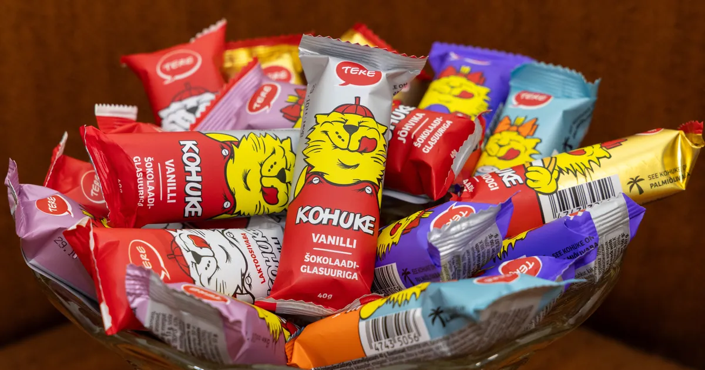

CHECK-LIST

Please check if you have:

* Valid travel document and/ or Schengen visa.
* Student Card/ISIC gives discounts almost everywhere.
* Travel insurance that covers medical costs, liability, etc.
* Personal items for hygiene, medicines, etc what you might need.
* Some cash just in case.
* Chargers for your phone/laptop/pad. The voltage is 220V, so check, if you need to bring a converter.
* Clothing: we can expect everything from the typical Estonian summer from hot sunshine to chilly showers. Be prepared to dress in **layers**, bring a hoodie and something **rain-proof**.

CONTACTS

**Emergency 112 -** general number for **police, ambulance and fire**. Use in case of emergency.

**Pharmacy** - With health problems, you can also go to the pharmacy for simpler questions and ask for advice there. The closest one is in the convenient store COOP <https://g.co/kgs/bgQmiSA>

**TalTech security +372 620 2112 -** Call this number (no texting) to **TalTech Security** team if anything happens on the campus and you need help.

**Hessnery Hostel -** Pärnu mnt. 453H, Tallinn 10916 - Google maps: https://g.co/kgs/mvW1dgU

[info@hessnery.ee](mailto:info@hessnery.ee), +372 504 4230

**TalTech campus -** Ehitajate tee 5, Tallinn 19086, Google maps: <https://g.co/kgs/Pj76XY7>

**Lectures** – ICT building – Akadeemia tee 165A, Tallinn - Goole maps: <https://g.co/kgs/wUd3pn9>

**Campus canteen -** Akadeemia tee 3, Tallinn - Google maps: [<https://g.co/kgs/hAPFWSz>](https://g.co/kgs/hAPFWSz)

The local program contact:

|  |  |
| --- | --- |
| **Maarja Tosso**  [maarja.tosso@taltech.ee](mailto:maarja.tosso@taltech.ee)  Whatsapp +372 56 299 039 | **Ülle Ainsoo**  [ulle.ainsoo@taltech.ee](https://livettu-my.sharepoint.com/personal/maarja_tosso_taltech_ee/Documents/!SUMMERSCHOOLS/SSC%202025/Citadel/ulle.ainsoo@taltech.ee)  Whatsapp +372 55 698 053 |

You can reach us if you have any general questions.

In order to better understand Estonians and feel comfortable among them, we have included some jokes about Estonians here 😀

* How to identify an extroverted Estonian?
* He stares at your shoes instead of his shoes during the conversation.

*****

A slow-witted Estonian and a quick-witted Estonian sit around a table and play poker. A huge pile of money rises in the middle of the table. Suddenly the electricity goes out and the room is plunged into darkness.

After a moment, the lights come back on, but the money is gone from the table. Who stole it? Answer: a slow-witted Estonian. The other characters are figments of the imagination.

*****

An Estonian, a German and a Frenchman are hiking in the jungle and see a dead elephant.

* "I wonder how I would manage to use every piece of this elephant," muses the German.
* "I wonder how tasty this elephant would be if you cooked it," ponders the Frenchman.
* "I wonder what this elephant thought of Estonia before it died," the Estonian ponders.

Looking forward to meeting you!! :)